**RIPv2**

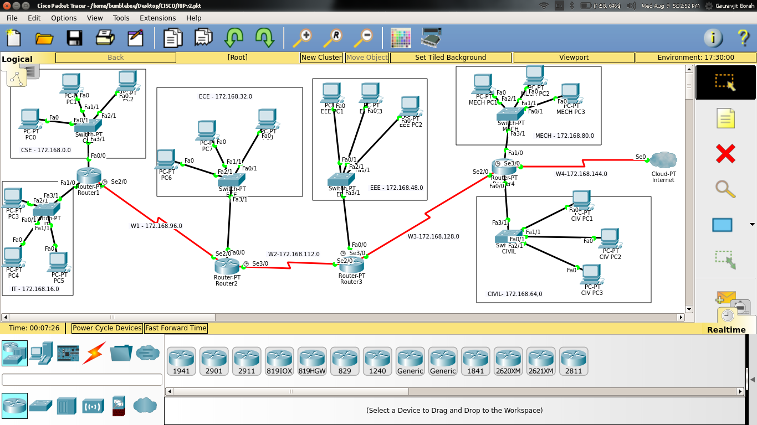

|  |  |  |  |  |  |
| --- | --- | --- | --- | --- | --- |
| NAME | N/K ADDR | SUBNET MASK | BROADCAST ADDR | CIDR | HOST ADDR RANGE |
| CSE | 172.168.0.0 | 255.255.240.0 | 172.168.15.255 | 20 | 172.168.0.1-172.168.15.254 |
| IT | 172.168.16.0 | 255.255.240.0 | 172.168.31.255 | 20 | 172.168.16.1-172.168.31.254 |
| ECE | 172.168.32.0 | 255.255.240.0 | 172.168.47.255 | 20 | 172.168.32.1-172.168.47.254 |
| EEE | 172.168.48.0 | 255.255.240.0 | 172.168.63.255 | 20 | 172.168.48.1-172.168.63.254 |
| CIVIL | 172.168.64.0 | 255.255.240.0 | 172.168.79.255 | 20 | 172.168.64.1-172.168.79.254 |
| MECH | 172.168.80.0 | 255.255.240.0 | 172.168.95.255 | 20 | 172.168.80.1-172.168.95.254 |
| W1 | 172.168.96.0 | 255.255.240.0 | 172.168.111.255 | 20 | 172.168.96.1-172.168.111.254 |
| W2 | 172.168.112.0 | 255.255.240.0 | 172.168.127.255 | 20 | 172.168.112.1-172.168.127.254 |
| W3 | 172.168.128.0 | 255.255.240.0 | 172.168.239.255 | 20 | 172.168.128.1-172.168.239.254 |
| W4 | 172.168.144.0 | 255.255.240.0 | 172.168.159.255 | 20 | 172.168.144.1-172.168.159.254 |